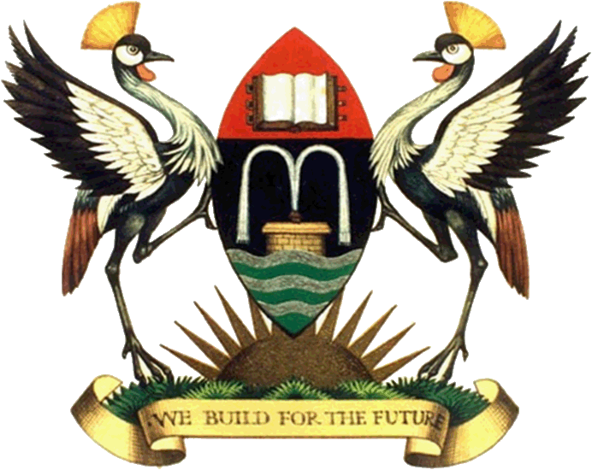

**COLLEGE OF COMPUTING AND INFORMATICS TECHNOLOGY**

By

MUBIRU CHARLES

14/U/9339/EVE

214004094

**DEPARTMENT OF COMPUTER SCIENCE**

**SCHOOL OF COMPUTING AND INFORMATICS TECHNOLOGY**

Dr. Ernest Mwebaze

March, 2017

**Coffee**

**Introduction**

Coffee is a drink made from the roasted and ground beanlike seeds of a tropical shrub, that can be served hot or iced.

Coffee is a very healthy drink that is loaded with beneficial nutrients that can improve our health. it can be served strong or very strong at most of the prominent cafes in town. Coffee beans can either be obtained from Robusta coffee or Arabica coffee.

**Background**

Coffee starts way back from the village where a farmer somewhere in Masaka district or Luwero district gets coffee seedlings and starts up a coffee plantation. With time, as the rains pour on theses grounds with the seedlings, they germinate and during the process of germination, irrigation is also incorporated when the rains stop coming.

**Description**

1. **harvesting**

After a period of approximately three years, the farmer in masaka is ready to harvest the coffee from the trees and this process of harvesting involves getting a collection basket where a farmer puts the beans collected from the trees. The process is iterative for all the trees.

After the harvesting process, the coffee is dried under the sun. The drying process can take on at most a week that’s if the sun has been shining steadily every day. The beans are put under the sun in the morning and then collected in the evening when the sun sets.

1. **Processing**

The now dry coffee beans are taken to a machine that is meant to remove the coffee husks and we remain with beans without husks. The coffee is poured in the machine, then after a series of processes, the output is gotten which is clean coffee beans without husks. The commonly used machine is a john Gordon made from the UK.

1. **Weighing**

Before processing, coffee is weighed to make sure that what comes out once weighed, should not be very different from what has been fed into the machine. The comparison is done by what we call an out tone whereby if you divide the output by the input, it should not be less than at least 55%.

1. **Market**

After the whole processing and weighing, coffee is taken to market. The common markets are companies around Namanve industrial park along jinja road.

Examples of these companies are Ugacof, Kawakom, Export Trading and Platinum commodities among others.

The above mentioned companies are the price setters of the final processed coffee from the different parts of Uganda i.e. Masaka, Luwero, Busoga.

Its these companies that further process the coffee to make it finer, they have grading plants that remove dust, stones and other unwanted things that come along with the coffee beans.

These machines further roast the coffee beans, the roasted coffee beans are then packed and displayed in supermarkets. The remaining beans that are not roasted are packaged and exported to different outside countries such the United Kingdom, Spain, Valencia among others.

1. **Market for roasted beans.**

The coffee shops visit different supermarket outlets such as Nakumatt, Uchumi, Shoprite to purchase the roasted beans that they use to make our coffee.

The packages of course range in prices according to different weights. This could be 1kg,2kg etc.

1. **Coffee makers**

The coffee shops have machines called coffee makers, the roasted beans are poured in these machines which undergo a certain process to give an output which is **coffee.**

**Conclusion**

The above process is the whole birth of the coffee drink that that is so common among shops like good African coffee in lugogo, café javas around town, and some popular restaurants in Uganda.